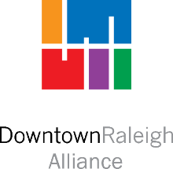

Community Engagement and Safety Ambassador Program
Request for Proposals

Contractor Intent Registration Form

The information provided in this form will be used to communicate information and respond to questions from potential Contractors. Complete and submit this form to Kimberley Jones via email at kimberleyjones@downtownraleigh.org no later than Friday, April 23, 2021.

Name of Applicant:
Official Business Name of Contractor:
Business Address:
Primary Contact (if different than Applicant)
Telephone Number:
Email Address:

